**Name :**

**Hafsa Waseem**

**Roll no:**

**SU92-BSSEM-S24-014**

**Subject :**

**DSA (Lab)**

**Section :**

**3A**

**Submitted to:**

**Sir Rasikh**

**Task no 3:**

**Implement a singly linked list with functions to insert a node at the start and at the end. Display the list after each insertion.**

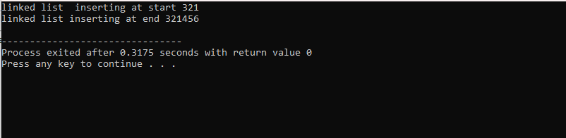

**Explanation :**

The singly list has three main functions:

* Insert at start (int data)

Inserts a new node with the given data at the start of the linked list.

* Insert at end(int data)

Inserts a new node with the given data at the end of the linked list.

* Display list()

Displays the current state of the linked list.

In the main function, we create an instance of the singly linked list class and demonstrate the insertion of nodes at the start and end of the linked list. After each insertion, the updated linked list is displayed.